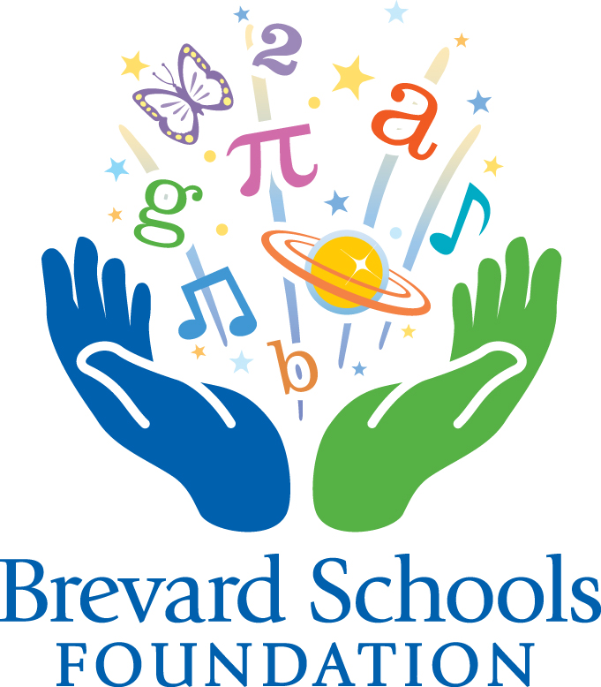
Deadline:
August 31, 2017
BRIGHT IDEAS CLASSROOM GRANTS PROGRAM
2017-18
Grant Guidelines

**Read entire packet before beginning your application.**

All Brevard County Public School teachers are invited to apply for classroom grant funding to support initiatives and programs in support of student achievement and improving teaching quality. The intention of Brevard Schools Foundation is to encourage teachers to implement innovative projects in areas of need where school budgets fall short or tax dollars cannot be used. These are competitive grants that will be awarded highest to lowest score in each category applied for until the funding runs out. All grants are contingent upon availability of funding.

TIP: Use the Bright Ideas Mini-Grants Program to meet your PD goals by 1) applying for the grant, 2) winning the grant, and 3) presenting the grant to your faculty with your principal’s sign off.

These grants are funded in part by the sale of “License for Learning” specialty tags and through the generous sponsorship of many businesses and individuals along with support from the Consortium of Florida Education Foundations (CFEF), in conjunction with the State of Florida Department of Education School District Education Foundation Matching Grant Program. Brevard Schools Foundation is pleased to dedicate these funds to invest in young minds through these grants.

Instructions and Policies:

- Schools may submit multiple different projects; however, only one application per teacher may be submitted. For team, grade-level or schoolwide projects, one lead teacher must be designated as the grant contact and person responsible for reporting.

- We invite you to view specific criteria of all sponsored grants in the Grant Opportunities – Description on pages 3-4. Meeting sponsored grant criteria will improve your chances of receiving a grant.

- All applications will be reviewed by at least three reviewers and must indicate what specific outcomes will be measured. Reviewers will consider 1) Creativity & Innovation (10 pts.), 2) Impact on Students (10 pts.), 3) Project Evaluation (10 pts.), 4) Organization (10 pts.), and 5) Improving Instructional Practice (10 pts.). Applications scoring below 35 points may not be considered for funding. Preference will be given to applicants
that have not already received funding in the past year. The recommendations for funding are brought for final approval to the Foundation’s Board of Directors.

-continued-

- Projects that demonstrate a colleague collaboration, or align with the priority focus areas of Social and Emotional Support, Consistent Discipline, Early Literacy, Middle School Algebra or Graduation Rate and College Readiness may receive bonus points of 2 points for each component.
- Grant recipients from the 2016-2017 academic year must have submitted a final evaluation to be eligible to apply for the 2017-2018 academic year.

Grant Reporting and Fiscal Documentation:

- The Foundation will provide your bookkeeper with a copy of your grant award letter. You should provide them with a copy of these grant instructions. These are also available on our website www.brevardschoolsfoundation.org under the Programs button, then Bright Ideas Grants the drop down menu.

- All grant funds received and deposited into a school’s internal accounts must be administered following Internal Accounts Procedures as the highest level of authority for purchasing and accounting processes. All Internal Accounts policies are to be followed and grant language does not supersede those procedures. Grantees should review their proposed budget and source of purchases with their school bookkeeper to ensure that you are following the policy. If your bookkeeper has questions about technology purchases, these can be directed to Wil Henzmann, henzmann.william@brevardschools.org or 633-1000 ext. 623.

- Grant funds and the materials/equipment they purchase must remain at the school where they are received. Any technology equipment purchased with the grant must be tracked and inventoried according to Brevard Public Schools Policies and Procedures.

- Unspent funds must be returned to the Foundation. When you accept a grant award, you are expected to carry out the project. If there are changes preventing grant implementation, you must notify the Foundation and return the funds within 30 days.

- Non-allowable expenditures include general administrative expenses, food/beverage/entertainment, support of interscholastic athletics, capital improvements, decorative items, awards/incentives, fundraising, pre-award costs, PDAs/cell phones.

- Documentation must be submitted with your final report showing how you spent the funds. Examples of acceptable documentation include: paid detailed invoices/receipts and copy of the check, bank statements, and/or procurement documentation.

Additional information:
- Application Deadline: August 31, 2017

- Grant recipients are expected to be notified and checks issued by early October.
- Applications may be downloaded from our website: www.brevardschoolsfoundation.org
- Questions? Contact Linda Filippini at 633-1000 ext. 454 or e-mail filippini.linda@brevardschools.org

-continued-
BRIGHT IDEAS GRANT PROGRAM
Sponsored Grant Opportunities and Criteria

General Purpose - “License for Learning” & CFEF Grants:


Classroom Grants (Up to $500 each)
All teachers may apply for grants of up to $500 involving a single classroom project in any academic discipline.

Schoolwide or Grade Level Specific Grants (Up to $1,500 each)
All teachers may apply for grants of up to $1,500. Projects in any category are eligible, but must impact student achievement in either an entire grade level, or entire school population.

Specific Purpose - Sponsored Grants:



Lockheed Martin Grant for STEM Projects (Up to $500/$1,500 each)
Grants will be awarded to grades k-12 for projects that further the skills and knowledge students learn by studying Science, Technology, Engineering and Mathematics (STEM).

Larry Stuntz Memorial Grant for STEM Projects (Up to $500/$1,500 each)
Grants will be awarded to grades k-12 for projects that further the skills and knowledge students learn by studying Science, Technology, Engineering and Mathematics (STEM). This grant is awarded in the memory of Lockheed Martin employee, Larry Stuntz.

-continued-

Wyland Foundation Grant for Marine Mammal Education (Up to $500/$1,500 each)
Grants will be available for grades K-12 for education through arts and sciences for the protection of Florida marine mammals. All teachers are eligible to apply with their project for either a classroom, grade-level specific or school wide project.



SunTrust Foundation Grants for Financial Education (Up to $500/$1,500 each)
Grants will be awarded for projects that help students become financially literate. All teachers are eligible to apply for either a classroom or grade-level specific or school wide project. Title I schools will be given preference.


Merritt Island Breakfast Rotary Club for Merritt Island Schools (Up to $500/$1,500)
Grants may be awarded for classroom or schoolwide/grade level projects. Schools applying for this grant must be located in Merritt Island to be eligible.

Health First “Making Kids Healthy” Grants (Up to $500/1,500 each)
Grants will be awarded for health and wellness activities, physical fitness, and/or nutrition activities designed to make kids healthy in grades k-12. Examples of acceptable

projects/requests can range from additional technology/software, curriculum materials, CPR training, innovative classroom projects that incorporate fitness into the regular school day, etc. Projects must have measurable outcomes. Physical Education teachers may apply for up to $1,500 and classroom teachers may apply for up to $500. Title 1 schools in Central and South Areas are eligible.


Northrop Grumman Grants for STEM projects (Up to $500/$1,500 each)
Grants will be awarded for Science, Technology, Engineering or Mathematics (STEM) projects in elementary, middle or high schools. Preference will be given to schools that have not already received a grant.

-continued-
Timeline:
Tuesday, August 8, 2017 Applications Released/posted on Web page
Wednesday, August 23, 2017 Grant Workshop, 3-5 pm, Viera HS, Media Center
Thursday, August 31, 2017 Applications Due in Brevard Schools Foundation office by 5:00 p.m.
September 21, 2017 BSF Board approval of grants (expected)
October 6, 2017 Winners notified and checks distributed by
Oct 1.- May 10, 2018 Project period & site visits
January 10, 2018 Mid-Year Progress Check Due
Friday, May 18, 2018 Final project reports due with photos, tracking report (if applicable) and remaining grant funds

Scoring Criteria
Each application may receive up to 50 points, plus 6 bonus points for a total maximum of 56 points. Reviewers will score for excellent, satisfactory or below satisfactory responses within these areas:

- Creativity & Innovation (10 pts.): Clearly identifies goals and objectives. Learning Plan relates to student achievement. Links the project with Florida Standards. Project reflects creative approaches to using proven methods.
- Impact on Student Achievement (10 pts.): The application demonstrates the impact on student achievement. The project enhances achievement by expanding or extending rigorous learning activities within and/or beyond the classroom.
- Project Evaluation (10 pts.): Evaluation design helps the teacher/school achieve stated goals. Evaluation methods demonstrate the impact of the project on the student and include measurable outcomes.
- Organization (10 pts.): All questions are answered and instructions followed. Budget and amount requested is reasonable and includes only allowable expenses. Prior grant reports have been turned in, if applicable.
- Improving Instructional Practice (10 pts.): Project demonstrates a clear vision for aligning the Florida Standards with improving teacher instructional practice. There is a defined focus on increasing one’s professional learning and transferring that professional understanding into classroom practice.
Project number: _____________
Foundation Use Only. Do Not Fill In.

BRIGHT IDEAS GRANT PROGRAM
APPLICATION - COVER PAGE
This is a blind application. Your school name or teacher’s names should not appear in narrative responses. The application pages 8-9 entitled “APPLICATION – PROPOSAL” should not exceed four pages and may be less. Attachments are not necessary or desired. Please send your completed application via e-mail to filippini.linda@brevardschools.org Attach the Cover Page and Certification page as one attachment and the Application Proposal pages as your second attachment. Do not combine them into one file. Completed applications are due Thursday, August 31, 2017. Remember to submit only one application per teacher and, if applicable, designate one lead teacher as the contact on grants submitted by a team.

Project title:

Name of School:

School phone:

Name of teacher: Personal phone:

Teacher e-mail address:

Names of additional teachers, if applicable:

Total funds requested: Not to exceed $500 for Classroom grants and $1,500 for Schoolwide/Grade-level grants.

Project number: _____________
Foundation Use Only. Do Not Fill In.
BRIGHT IDEAS GRANT PROGRAM
APPLICATION - TEACHER CERTIFICATION PAGE

I certify the information in this application is accurate and complete to the best of my knowledge. Acceptance of any Brevard Schools Foundation grant signifies my willingness to:
1) Carry out the grant project and notify the Foundation, if there are any major changes.
2) File the Mid-Year Checklist by January 10, 2018 and the Final Report by Friday, May 18, 2018, including the fiscal documentation . (Note: Final reports must be received in order to be considered for future grants.)
3) Write a short letter of appreciation to the grant sponsor and send to the Foundation.
4) Present my project in workshops, in-services and/or meetings and/or participate in a site visit, if asked.
5) Permit appropriate news media coverage of the project or promotion of the program by the Brevard Schools Foundation. Acknowledge Brevard Schools Foundation on my own publicity.
6) Provide a copy of the grant guidelines to the school bookkeeper.

_____________________________ _____________________________
Teacher’s Signature Principal’s Signature

Date Date

Project number: _____________
Foundation Use Only. Do Not Fill In.
BRIGHT IDEAS GRANT PROGRAM
APPLICATION – PROPOSAL
(Remember - No more than four pages.)

Project Title:

Brief Project description (Describe in 500 words or less your project proposal, why it’s needed, how it’s going to tie into Priority Standards and outcomes to be measured):

- Number of students expected to benefit:

- Grade level(s):

- Subject (Please check ONE primary focus area):

Art
Geography
Health/PE
History
Language Arts
Mathematics
Music
Other
Science
Social Studies
Special Needs Students
STEM Education
Technology

- I would like my grant to be considered for the following sponsored grant(s):

Desired Results/Priority Florida Standard (1-2 max. List Standard number and description)

Evidence/Assessment (Describe in 1,000 words or less how you will measure outcomes for and evaluate your project. Include what metrics you will use):

Learning Plan/Activities (In 1,000 words or less describe what you are proposing to do and how project activities will meet the need you described above.):

Project timeline(Detail your timeline from project start to completion. Include all pertinent milestones that occur during the grant project period, Oct. 1, 2017 - May 18, 2018):

Focus on Improving Practice (List IPPAS Dimension and Element to show how the project is going to improve your instructional practice):

Bonus Points: Does this project include a colleague collaboration, or align with the priority focus areas of Social and Emotional Support, Consistent Discipline, Early Literacy, Middle School Algebra or Graduation Rate and College Readiness? If yes, briefly describe:

Budget for the proposed project:
Category of Expenditure Amount Description of Expenditure
Classroom materials
Travel
Program Supplies
Computer Software
Computer Hardware*
(*see instructions for required tracking)
Other Equipment (not computers)

Printing *
(*only if related to program implementation)
Tuition/Training/Conferences
Admission Fees
Room Rental Fees

Total grant funds requested: $
List other sources of funds, in-kind donations or school resources to be used in project implementation, if project budget exceeds grant funds requested and/or your project budget includes non-allowable grant expenses, as listed in the guidelines:

